

**BCA Third Year**

**Semester : VI**

**Title of Project**

**CHAT-VERSE :- The Web Chat Application**

Anurag Mahada (20210801070)  
Umesh Patil (20210801109)  
Vikram Jadhav (20210801133)

**Entity Relationship Diagram**

This is an ER model of a Chat Application. The entities are represented in rectangular boxes and relationships between different entities are represented by a diamond shaped box.

Here is the ER Diagram.

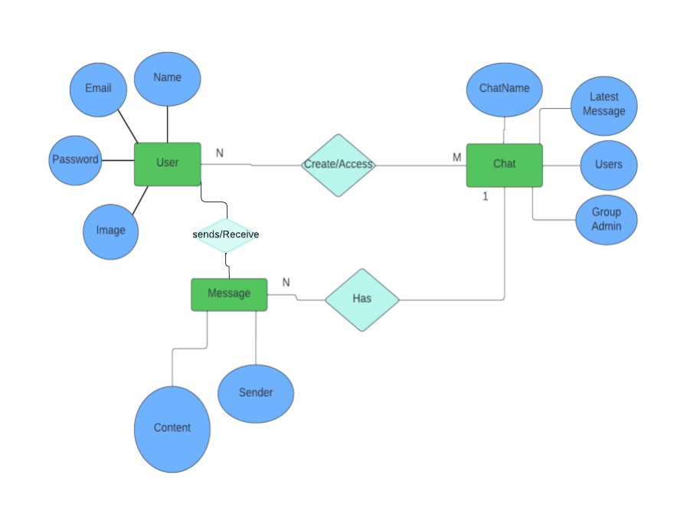

**Data flow Diagram (DFD)**

Following are application’s DFD level 0, 1, 2.

**Context level (0 Level) DFD :**

The Zero Level DFD is an abstract view of overall system. This is also called as Context Diagram in which entire system is represented as single process with

its relationship with external entities such as admin, Customer etc.

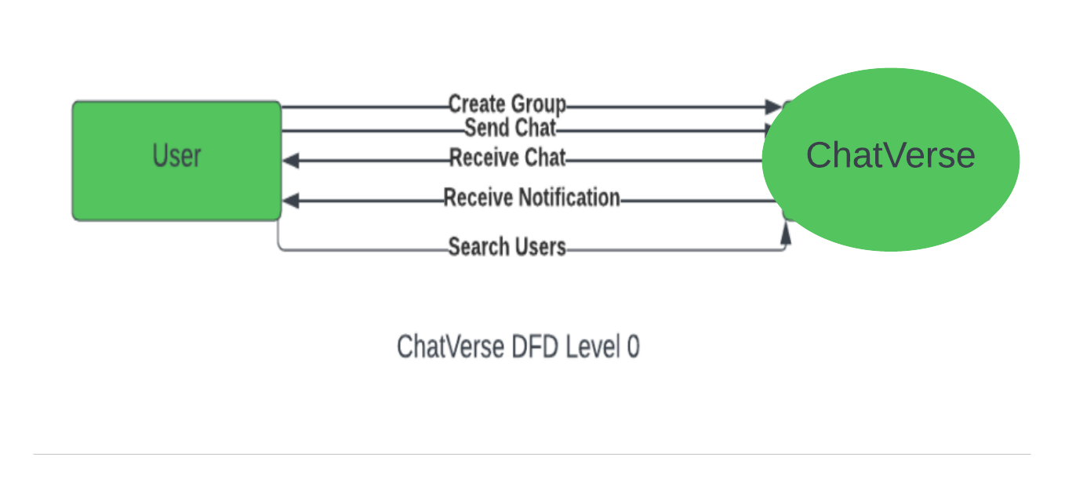

**Level 1 DFD :**

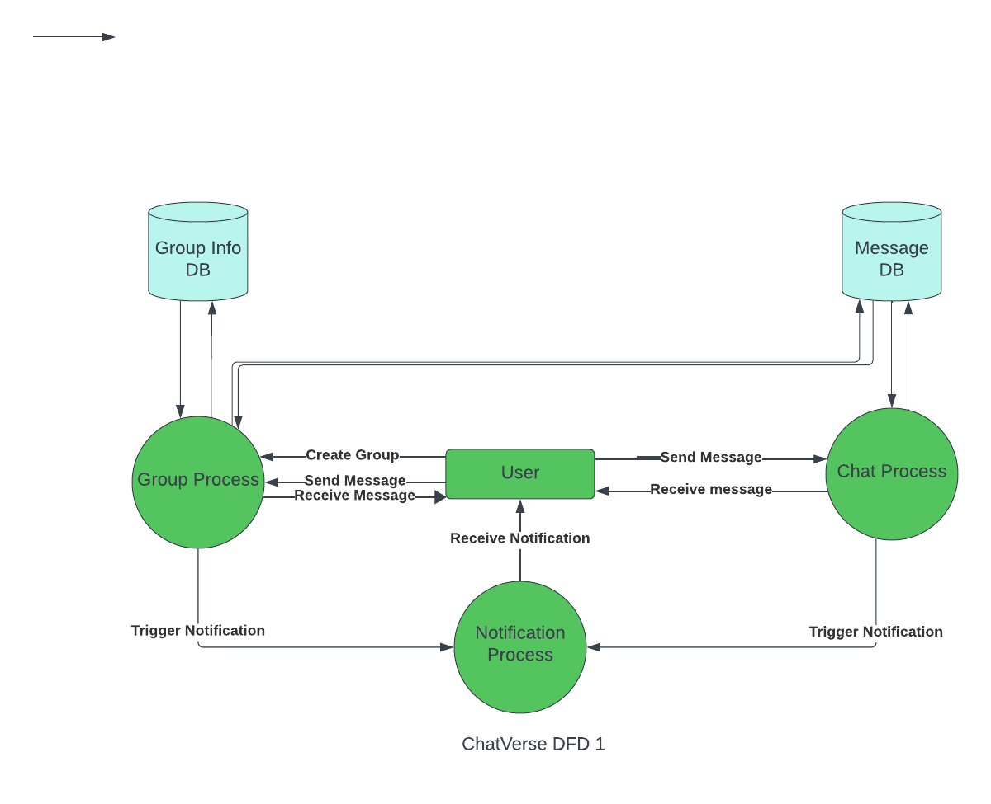The first DFD of Chat Application shows more details of processing. Level 1 DFD list all the major sub processes that makes the entire system.

**Level 2 DFD :**

Level 2 DFD for Chat application dives even deeper into the concept of Level 1 DFD.

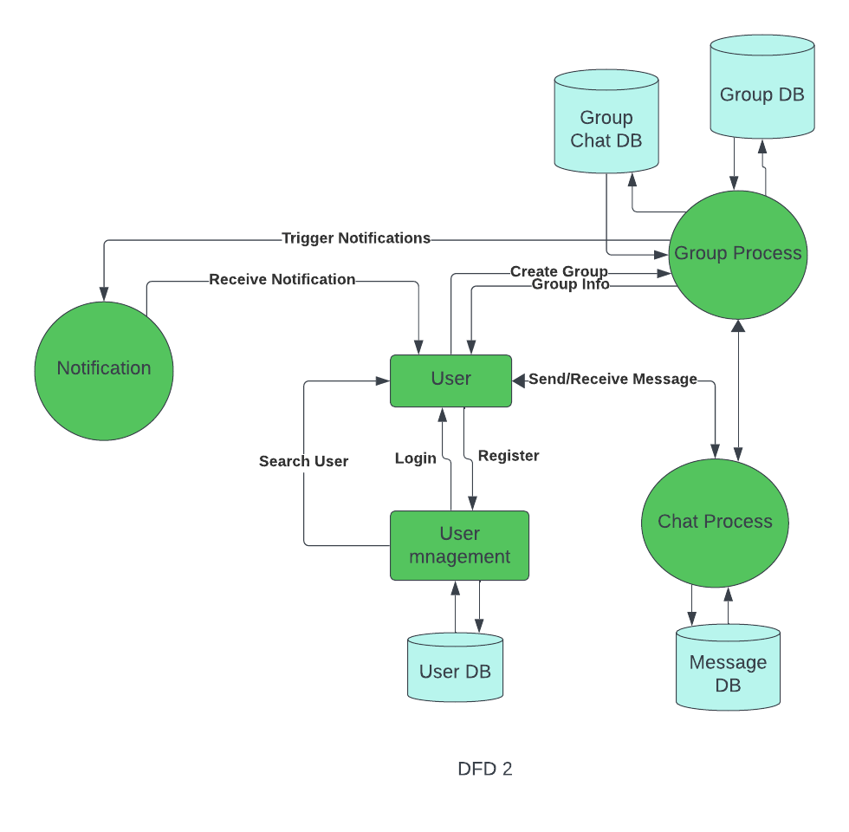

**Flowchart**

A flowchart is a visual representation of a process or algorithm. It is used to describe the sequence of steps and decisions required to perform a task.

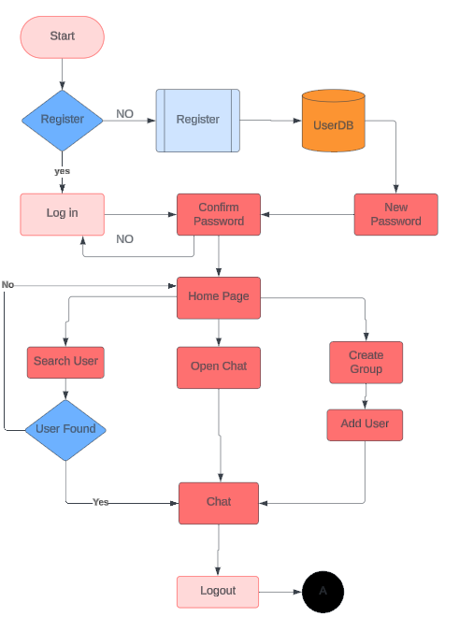

**Class Diagram**

a class diagram in the Unified Modeling Language (UML) is a type of static structure diagram that describes the structure of a system by showing the system's classes, their attributes, operations (or methods), and the relationships among objects.

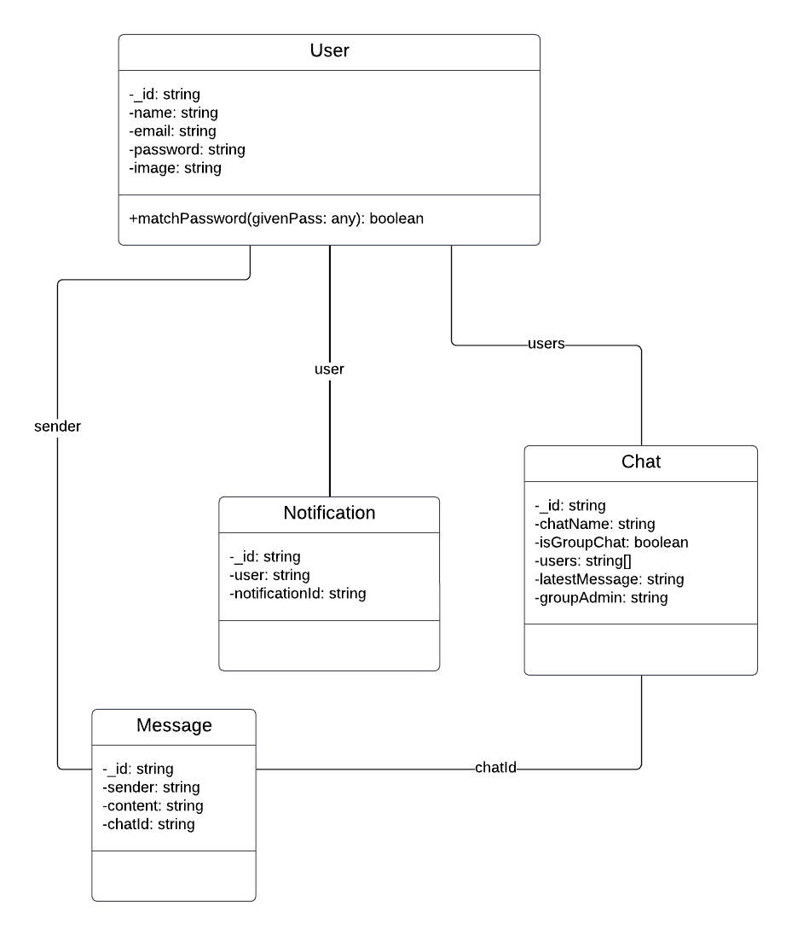

**Use Case Diagram**

A use case diagram is a type of Unified Modeling Language (UML) diagram that is used to model the interactions between a system and its actors.

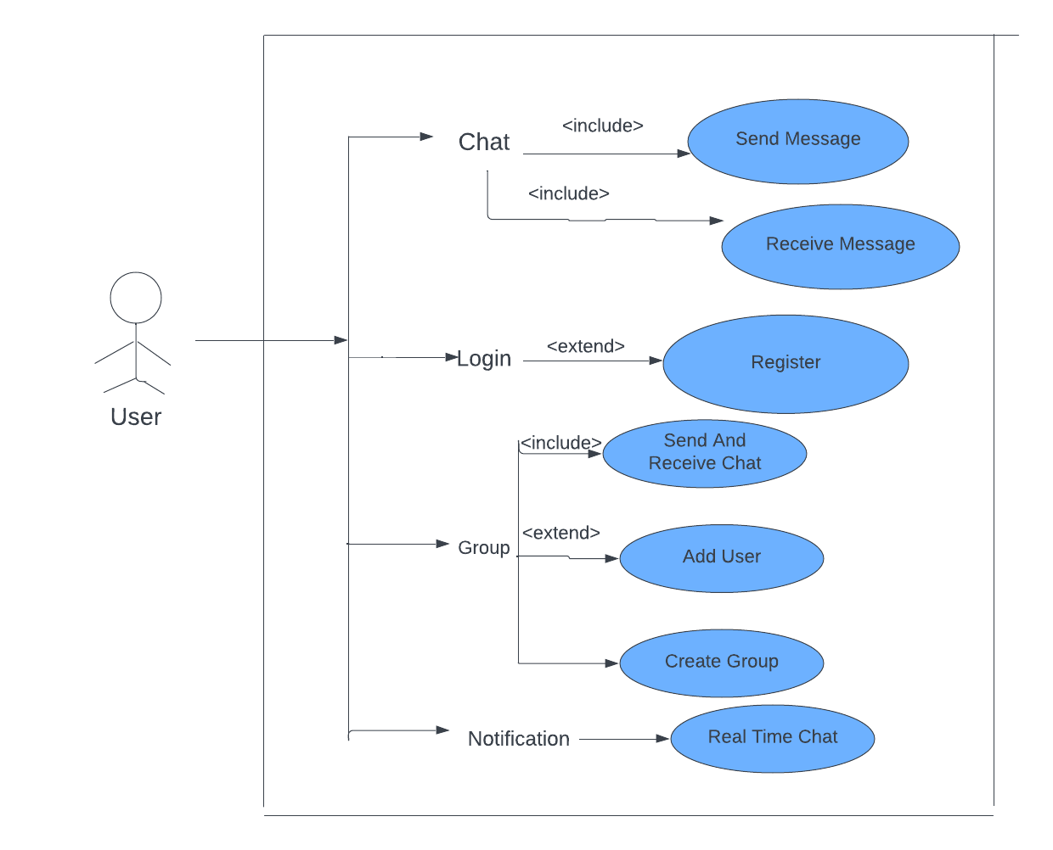

**Activity Diagram**

An activity diagram is a type of Unified Modeling Language (UML) diagram that is used to model the workflow of a system. It shows the flow of control between activities and the order in which they occur.

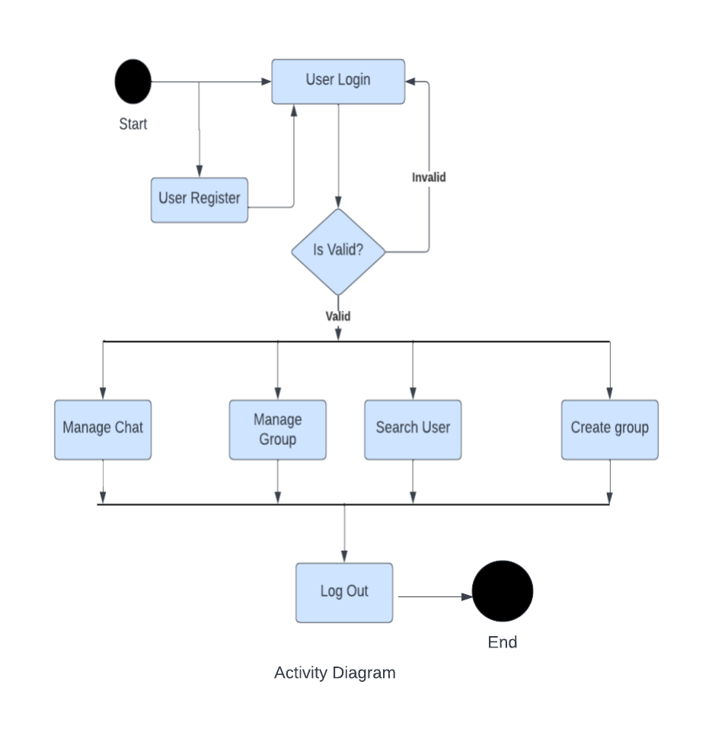

**Sequence Diagram**

A sequence diagram is a type of Unified Modeling Language (UML) diagram that is used to show the sequence of messages exchanged between objects and the order in which they occur.

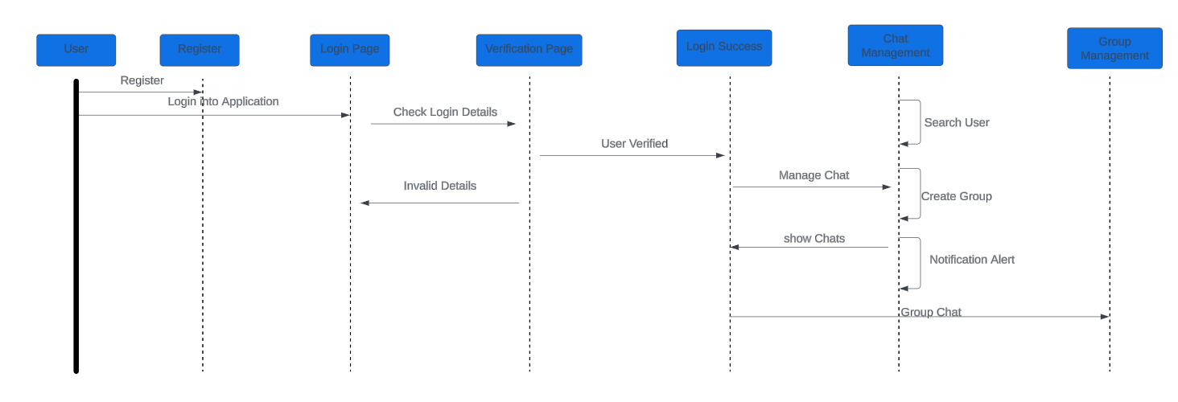

**Pseudocode**

* Pseudocode for Chatverse
* UserAuthentication Functions function login(userCredentials):
  + Authenticate the user using mongodb if authenticationSuccessful:

currentUser = getUserInfo(userCredentials) showHomePage()

else:

showErrorMessage()

function logout():

# user loggedout

function getUserInfo(userCredentials):

* + Retrieve user information from Database
* Home Page Functions

function showHomePage():

Function Chat():

* Fetch a chat Record from Database return chats

function displaychats(chats):

* Display a list of chats on the home page for each User friend :

# group Creation Functions

function creategroup(users):

* + Create a new Gorup in Database if GroupCreatedSuccessfully:

showHomePage()

else:

showErrorMessage()

* Group Details Functions

function GroupDetails(users):

Displaychats(chats)

Send Chat Functions

function sendchat(Message){

if messageSendSuccesfully:

receiveResponce(message)

else:

showErrorMessage()

}

function receiveResponce(message):

return response;

* Profile Page Functions function viewProfile(user): displayUserProfile(user)

function displayUserProfile(user):

# Display user's profile information

* Main Application function main():

if userIsLoggedIn(): showHomePage()

else:

promptUserToLogIn()

main()

**DATA DICTIONARY**

|  |  |  |  |  |
| --- | --- | --- | --- | --- |
| **User** | | | | |
| **Field Name** | **Data Type** | **Field Length** | **constraint** | **Description** |
| **Id** | **ObjectId(automatically generated by MongoDB)** | **No specific length limit** | **Not null** | **Id of the User** |
| **name** | **String** | **25** | **Not null** | **Name of the User** |
| **password** | **String** | **10** | **Not null** | **Password Of the User** |
| **Image** | **String** | **50** | **Not null** | **Image Url of the User** |

|  |  |  |  |  |
| --- | --- | --- | --- | --- |
| **Chat** | | | | |
| **Field Name** | **Data Type** | **Field Length** | **constraint** | **Description** |
| **Id** | **ObjectId(automatically generated by MongoDB)** | **No specific length limit** | **Not null** | **Id of the Chat** |
| **Chatname** | **String** | **50** | **Not null** | **Chat Name** |
| **IsGroupChat** | **Boolean** | **2** | **Not null** | **True If it is Group chat else False** |
| **User** | **ObjectId** | **No Specific Length Limit** | **Not null** | **users participating in the chat** |
| **Latest Message** | **ObjectId** | **No Specific Length Limit** | **Not null** | **latest message in the chat** |
| **GroupAdmin** | **Objectid** | **No Specific Length Limit** | **NOt null** | **user who is the group admin** |

|  |  |  |  |  |
| --- | --- | --- | --- | --- |
| **Message** | | | | |
| **Field Name** | **Data Type** | **Field Length** | **constraint** | **Description** |
| **Id** | **ObjectId(automatically generated by MongoDB)** | **No specific length limit** | **Not null** | **Message** |
| **Content** | **String** | **50** | **Not null** | **Content in message** |
| **ChatId** | **ObjectId** | **No Specific Length Limit** | **Not null** | **chat that the message belongs to** |

|  |  |  |  |  |
| --- | --- | --- | --- | --- |
| **Notification** | | | | |
| **Field Name** | **Data Type** | **Field Length** | **constraint** | **Description** |
| **Id** | **ObjectId(automatically generated by MongoDB)** | **No specific length limit** | **Not null** | **unique identifier for the notification** |
| **User** | **ObjectId** | **No Specific Length Limit** | **Not null** | **who will receive the notification** |
| **NotificationId** | **ObjectId** | **No Specific Length Limit** | **Not null** | **message that triggered the notification** |

Note: ObjectId is a type provided by Mongoose, representing a unique identifier for a document in a MongoDB database.

**DECISION TABLE**

|  |  |  |  |  |  |  |  |  |  |  |  |  |  |  |  |  |  |
| --- | --- | --- | --- | --- | --- | --- | --- | --- | --- | --- | --- | --- | --- | --- | --- | --- | --- |
|  | **Condition** |  |  | 1 |  |  | 2 |  |  | 3 |  |  | 4 |  | |  | |
|  |  |  |  |  |  |  |  |  |  | |  | |
|  |  |  |  |  |  |  |  |  |  |  |  |  |  |  | |  | |
|  | **Userid** |  |  | **F** |  |  | **T** |  |  | **F** |  |  | **T** |  | |  | |
|  | **Password** |  |  | **F** |  |  | **F** |  |  | **T** |  |  | **T** | |  | |
|  | **Action** |  |  |  |  |  |  |  |  |  |  |  |  |  | |  | |
|  | **Login to** |  |  | **Access** |  |  | **Access** |  |  | **Access** |  |  | **Access** | |  | |
| **application(Home)** | |  |  | **Denied** |  |  | **Denied** |  |  | **Denied** |  |  | **Granted** | |  | |
|  | **Manage chat** |  |  | **NO** |  |  | **NO** |  |  | **NO** |  |  | **YES** |  | |  | |
|  | **Manage group chats** |  |  | **NO** |  |  | **NO** |  |  | **NO** |  |  | **YES** | |  | |
|  | **Receive Notification** |  |  | **NO** |  |  | **NO** |  |  | **NO** |  |  | **YES** |  | |  | |
|  | **Search Users** |  |  | **NO** |  |  | **NO** |  |  | **NO** |  |  | **YES** | |  | |

F : False

T : True

**Decision Tree**

